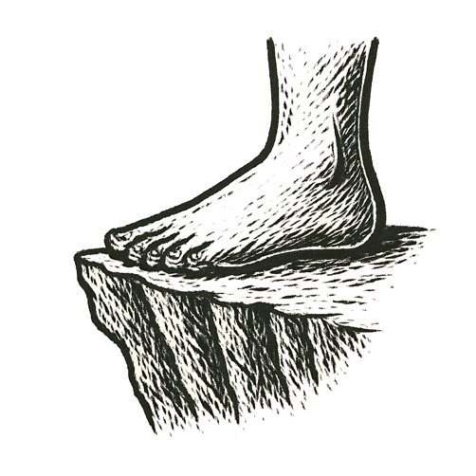
The moon hung thin over black waves, stars cold and sharp in the sky. A fire flickered on a rocky shore, casting small faces in orange light. Eyes watched the dark water with fear and wonder.
Behind them lay parched earth, hunger, the scent of death. Ahead, an endless stretch of sea, quiet and unknowable.
A mother held her child close, the night wind whispering promises and curses. Elders argued in low voices, the taste of ash on their tongues.
A raft scraped against wet sand. Hands grasped it, knuckles pale, splinters biting. One by one, figures climbed aboard. Breath caught. The raft shoved off.
The shore shrank. The old world slipped behind them, silent.
Across a narrow strait, the future waited.
A thin line between extinction and everything to come.

How far must we carry it — just to survive?

